VisionForge: Mini Project 2

Mentors: Isha Jain, Karan Mundhra, Umang Sinha

Due date: 19 Jan, 2024

Due time: 11:59 PM

Car Parking System

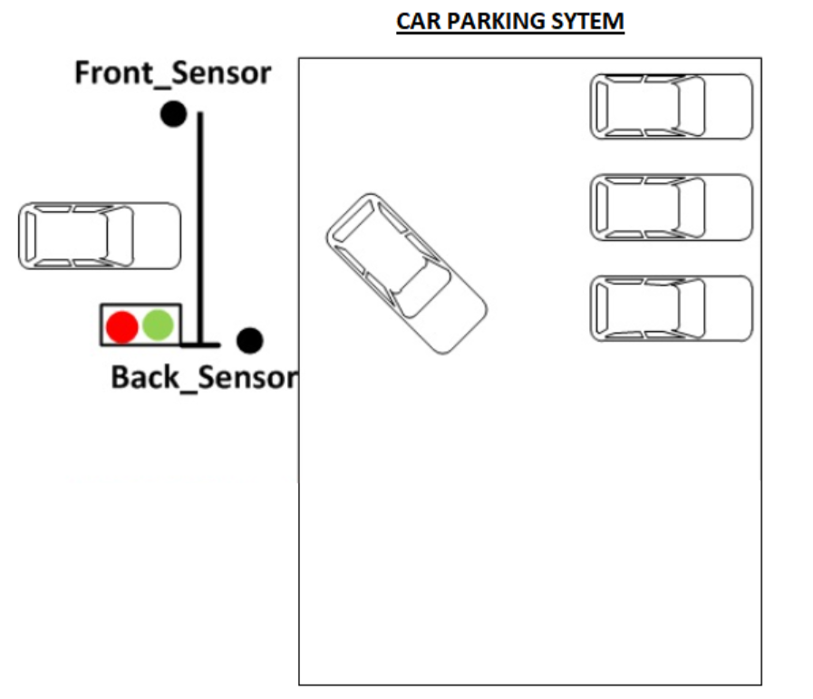

Imagine designing a futuristic Verilog code for a smart car parking system! At the entrance of this advanced parking lot, we have a high-tech sensor eagerly waiting to detect the arrival of a vehicle. Once the sensor spots a car, it triggers a magical sequence – the system prompts the driver for a secret password to unveil the gateway to parking paradise!

Now, here's where the Verilog wizardry begins. Picture a digital guardian that checks if the entered password aligns with the mystical correct password. If it's a match, voila! The gates swing open majestically, inviting the car to gracefully glide into its designated spot.

But, ah, the plot thickens! If, by any chance, the system senses that there's already a car enjoying the VIP parking experience inside, it doesn't panic. Instead, it calmly locks the gates and shifts into a mode where it challenges the next approaching car to present the correct password for entry.

Here is the flow chart of how the Car Parking system works!

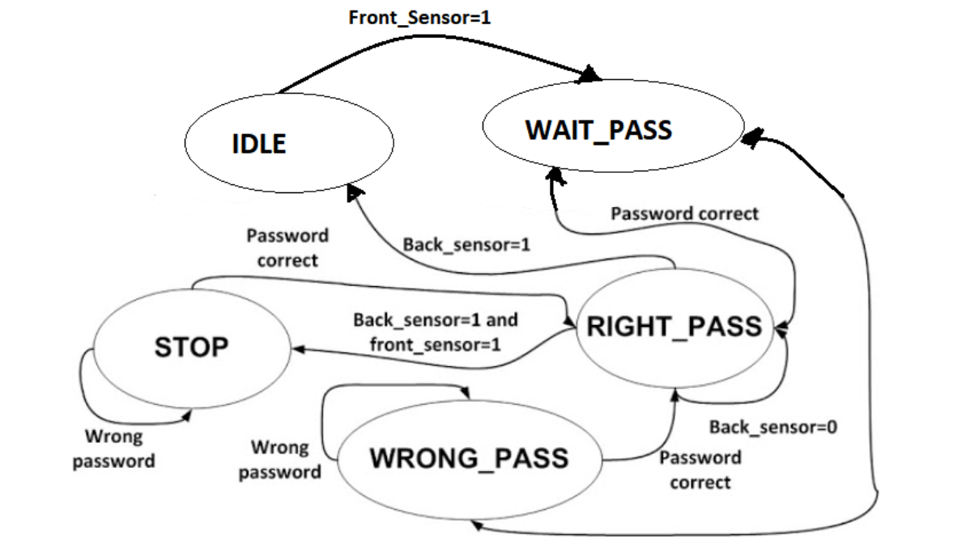

***Note: Collaborative undertake and submit this project as a group!***

